Prince George & District Elizabeth Fry Housing Society

Annual Report

We don’t Build Housing, We Build Communities

I am much honored to complete my first year in review for the Elizabeth Fry Housing society. I have been immersed into the complex fabric of social housing. The fabric of social housing starts with our vision that everyone deserves safe, affordable, housing. This vision guides our work as we support women, individuals and families with safe housing. We strive to create blended communities that embrace diversity in backgrounds, income, and family composition. This provides the opportunity for a micro culture unique to each of our housing complexes, which promote and support thriving families.
For virtually all our history, Elizabeth Fry has used the lens of gender, equity, and equality to improve the lives of those we serve. This year was again challenging as we entered year two of the global pandemic. We pivoted to provide additional sanitizing and took that extra moment to connect with clients who often were anxious and concerned with the unknown direction of the pandemic. Staff within the Housing Society provide the tools and skills to not only repair a building but also to empower the independence of women, individuals, and families.
This year has been a very productive and busy year. Rainbow Housing project was very active with the replacement of balconies, sliding glass doors, and garage doors to mention a few items. On the inside essential heating components were also updated. Staff went out of their way to ensure that everyone was informed and supported throughout the construction.
The most anticipated construction was occurring on 14th Avenue in Prince George. My Sister’s Place continues to grow into its footprint which will provide 24 hour crisis housing – Amber House, second stage housing and long term housing through a women led tenancy lens. This project has an anticipated completion date of summer 2022.
It has been a momentous year. More than ever, I wish to thank our staff, donors, and funders for your generous and life changing support. I would also like to thank the Board of Directions whose passion, dedication, and support has been instrumental throughout my first year.
Respectfully submitted,
Shannon Smith

Family Housing

Irwin Place is a 40-unit townhouse development located at 1444 Irwin Street. With our grand opening in June of 1997, Irwin Place has provided homes for approximately 343 individuals and families.

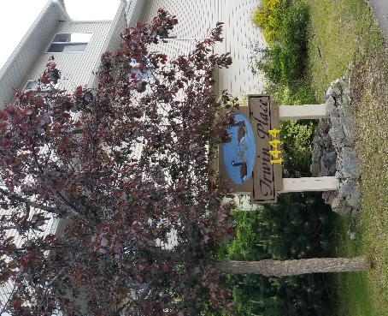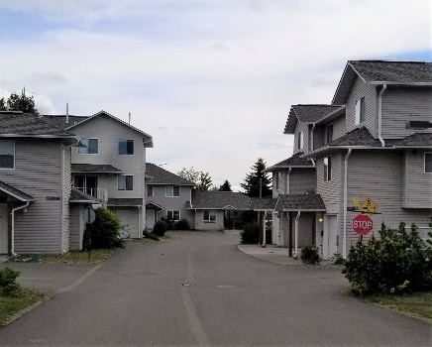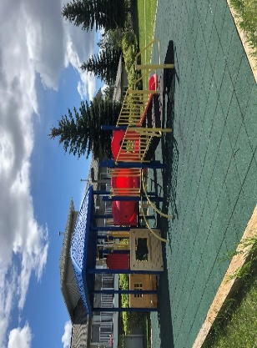

Rainbow Village is a 40-unit townhouse development located at 4066 Rainbow Drive. With our grand opening in December of 2000, Rainbow Village has provided homes for approximately 222 individuals and families.

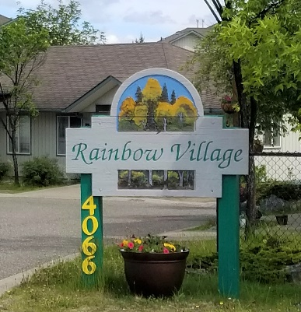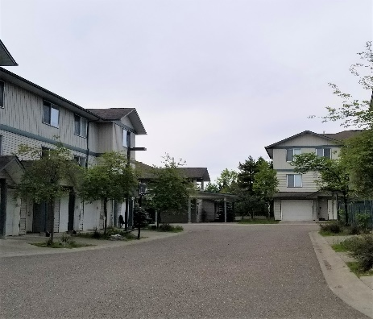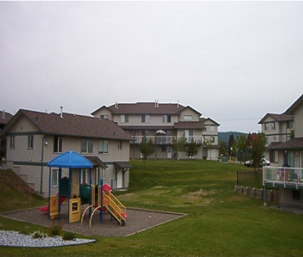

Nexus Place
Nexus Place is an 11-unit apartment building operating under the Homeless-At-Risk Program through BC Housing. Our tenants at Nexus Place are women with children who are fleeing unsafe situations. The location of Nexus Place is kept confidential for the safety and well-being of our tenants. Since 1996 Nexus has been home for approximately 269 families.

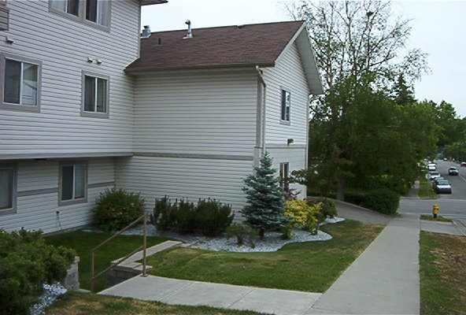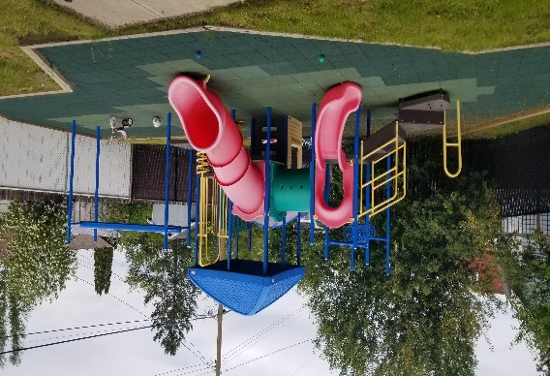

Seniors Housing
Elizabeth Fry Place is a 36 unit apartment building owned by BC Housing. The Elizabeth Fry Housing Society has an operating agreement to provide homes for seniors (55 and older) and people living with disabilities. Since the grand opening in April of 2012, Elizabeth Fry Place has been home to 86 individuals.

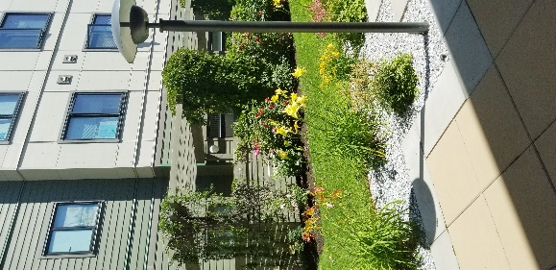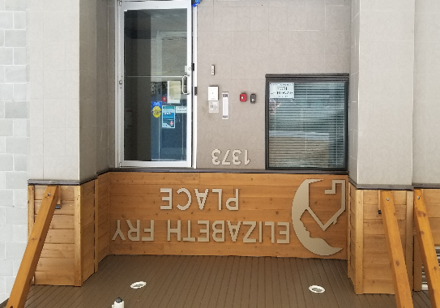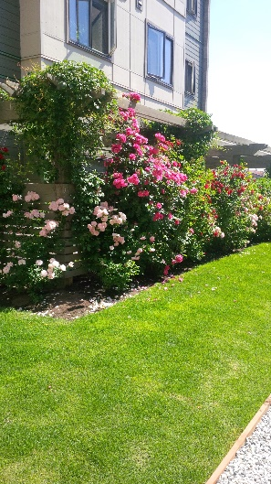

How our housing works:
Rainbow Village & Irwin Place Programs:
These development are comprised each of 16 low end market units whereby the rent is based on 85-90% of the tenants of these units are individuals and families that would pay more than 30% of their gross household income on their rent in the private market. BC Housing provides the Society with a small subsidy for each of these units based on the economic cost to operate these units versus the rent charged.

The 24 remaining units are classified as “rent geared to income” or RGI units. Rent for these units are determined by the gross household income. These rents are called Tenant Rent Contributions (TRC) and BC Housing provides subsidies directly to the Society to top up the balance required to meet the economic cost of operating the units.

Once family incomes become higher than the allowable limits (which are based on the size of the unit), the tenants are given notice as they are able to move into the private market to make room for another family in need of subsidy.
All tenants are responsible for paying their own utilities.

Nexus Place
Nexus Place units are all classified as RGI units and utilities are paid for by the Society.

Programming
All of our tenants must be able to live independently, as we do not provide supports like housekeeping, laundry and meals.

The exception to this is that at Nexus we provide a Tenant Support Worker. This support worker works part time and provides on-site weekly individual meetings with tenants to ensure they are getting the information and referrals they required. The TSW also provides group activities at Easter, Halloween, Christmas, Mother’s day as well as bbq’s and other networking activities. Group activities have been a challenge due to COVID-19 these past years.

TENANT SUPPORT WORKER STATS

Annual total days on site: 141
Average monthly days on site: 11.8
Annual total of tenants seen: 473
Average monthly number of tenants seen: 39.4
Annual total number of tenant contacts: 843
Average monthly number of tenant contacts: 70.3
Annual number of tenant emotional supports: 258
Annual number of referrals: 299
Average monthly number of referrals: 24.9
Transfers from Nexus to BC Housing units: 2
Average monthly number of tenant’s connected to food service providers to improve food insecurities: 4.3

Recognized special dates and gift giving
Group activities: 6
Easter-Easter treats were delivered to the tenants and their children
Halloween-Pumpkin patch (pick a pumpkin) and candy bags for the Nexus children
Christmas-Christmas crafting and movie nights (x2) and donation dinner
Mother’s Day- Build your own flower pot (make and take)
Circle of Security Parenting program

Referrals
Counselling and Family Support  Canadian Mental Health Association  Community Counselling Center  Prince George Native Friendship Centre  Carrier Sekani Family Services  Elizabeth Fry Society  Active Support against Poverty  P.G. Parent Support Services  Foundry  Ministry of Children and Families  John Howard Society  Northern Interior Autism Society  Autism BC  Pacific Autism Family Network  AIM-Hi  United Way-Parent Support Services  Intersect  S.O.S. Society  Hospice Society-Rainbows Program  Axis Family Resources | Education and Employment  College of New Caledonia  UNBC  Community Vocational Training Center  KOPAR Employment Services  Work BC  Community Futures  Gov’t Aged out Program
Health Care
University of Northern British Columbia
Prince George Urgent and Primary Care Center
Salveo Medical Clinic
Blue Pine Clinic
Northern Health Diabetes Clinic
Canadian Mental Health Association
Yu Be Yah Primary Care

Food Programs and Emergency Supplies  St. Vincent de Paul  Prince George Native Friendship Center  Salvation Army | Housing  Ketso Yoh Housing  Aboriginal Housing  BC Housing  Advocating for Women and Children (AWAC)  Phoenix Transition House  Amber House
Law  Parents Legal Centre  BC Legal Aid  Prince George Native Friendship Center  Family Law lines  Family Duty Counsel  Mediation  Family Maintenance | Income  Income Assistance BC  Disability Assistance BC  Employment Insurance  Immigration  IMSS
Transit  United Way-Bus passes  Leisure Services  Prince George Aquatic Centre  Prince George Public Library  YMCA | Addictions Support  Alanon  AA  Poverty Reduction  Active Support against Poverty

Maintenance
We have a strong maintenance program that incorporates routine, preventative and corrective maintenance to keep our buildings in a good state of decoration and repair. Throughout 2021, a total of 286 maintenance work orders were created. Of those, 272 were completed in their entirety. A special thank you to our hard working maintenance team for meeting the needs of our tenants and keeping our buildings well maintained.
Unit Turn-overs
Irwin Place 15 Nexus 15
Rainbow 11 Elizabeth Fry Place 10 Total: 51

Special Projects
Rainbow Capital Improvements
We are grateful to have received funding from BC Housing to complete a capital improvement project at Rainbow Village. The scope of the project included: new roofs, gutters, balcony membranes, posts, balcony railings, patio doors, entry doors, hot water tanks, privacy glass for balconies, bathroom fans and garage doors. The work was completed over the span of one year starting in spring of 2021 and ending in spring of 2022. A special thank you to all of our tenants who were very patient as we worked through this large renovation project.

New Furnaces
We were successful in obtaining a grant through the Energy Conservation Assistance Program and received all new furnaces at Rainbow Village and some were also installed at Irwin Place. This is a program provided by BC Hydro and Fortis Gas.

The Staff of

Prince George & District

Elizabeth Fry Housing Society

Shannon Smith, Executive Director

Kathi Heim, MA, Executive Director
Claudette Plante, Manager
Bernadette Goudreau, CPA, CMA, Finance Manager
Leona MacPherson, Housing Assistant
**Brady McEvoy, Maintenance Coordinator
Todd Kellington, Maintenance
Bridgit Rolf, Janitor
Denise Johnson, Janitor (Covid-19)

** no longer with Society

BOARD OF DIRECTORS

Suzanne Jackson, President
Cathe Wishart, Director Penny Fahlman, Director
Selen Alpay, Director

